Chronicle school: Friday, April 29, 2026

ENGLISH THEATRE BRINGS MYSTERY TO CARNOT SCHOOL!

​By a student reporter: Damien Gautron

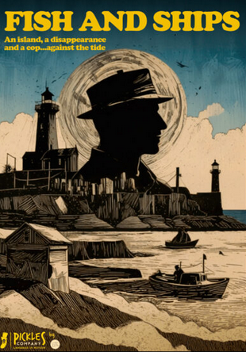

​Last Thursday, an English theatre company (The Pickles Company) visited our school to perform the play "Fish and Ships". The event took place in the No Man's Land and gathered several year-eleven classes.
​
The story takes place on Great Island, where a detective, Mike O'Neil, is sent to investigate the death of the fisherman Bob O'Leary. As the investigation unfolds, strange elements appear, including the legend of the ghost ship called the "Black Seagull". However, it is revealed that the case is linked to illegal fishing activities and smuggling.
​
During the play, the actors interacted with the public, which made the play more interesting. The actor of Mike O'Neil (Tom) was both funny and determined, while the play was engaging.
​
Some students said they had found the play easy to understand, while others explained that they had enjoyed the mix of humour and suspense. One of the actors answered: "The interaction of actors with the public made the event very relaxed, and the clothes of the actors and the decorated scenery created the lively atmosphere of an isolated island."

​Overall, the event was both entertaining and educational. It allowed students to learn English while enjoying a live mystery play.

There were also theatre workshops that got the students interested!

